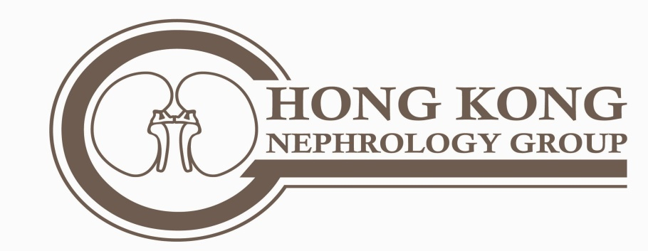

The Hong Kong Polycystic Kidneys Disease Support Group
(a subsidiary of the Hong Kong Nephrology Ltd)
Rm 811A, Champion Building,
301 Nathan Road, Kowloon, Hong Kong

Email: kidney@hkma.org Fax: 3523 1405
Website: www.kidney.hk https://www.facebook.com/PCKDHK/

Nature of the HK PCKD Support Group

Polycystic Kidney Disease affects 1/1000 people and there are about 5000 affected people in Hong Kong. Contrary to popular belief, much can be done to help these patients. All doctors, nurses, patients and relatives with interest in this disease are welcomed to join this group. Admission is free and activities include health talks on the disease, dietary measures and other things to observe for PCKD patients. There would also be sharing sessions from PCKD patients.

Application form:

Name in English ________________________ Name in Chinese: ____________________

Gender: ________

Contact phone: ____________________ Contact email: ________________________

Address: ____________________________________________________________

I am interested in joining the HK PCKD support group. I am a

Patient / relatives/ doctor/nurses/ person interested in PCKD (delete where inappropriate)

_____________________________ (signature)

